2 – VPL

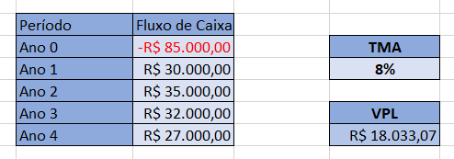

3 - Payback

85.000 / (30.000,00 + 35.000,00 + 32.000,00 + 27.000,00) = 0.68

4 – ROI

(30000+35000+32000+27000-85000) \* 100 / 85000 = 45,8%

5 – TIR

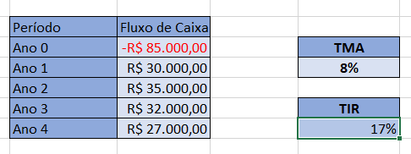

6 – VPL

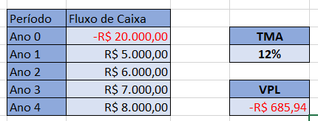

7 – 20000 / ( 5000 + 6000 + 7000 + 8000) = 0,76 a.a ou 9,2 a.m

8 – (5000 + 6000 + 7000 + 8000) / - 20000 = 10,98%

(1 + tir)^4

9 – JP = 6,1%

VJ = 20000 \* 6,1% = 1224,07

VT = 21.224,07

10 – 12500 – 10000

2500 / 100 = 25%

11 – J = 15,000 \* 0,03 \* 36

J = 16.200 / 36

J= R$450,00